
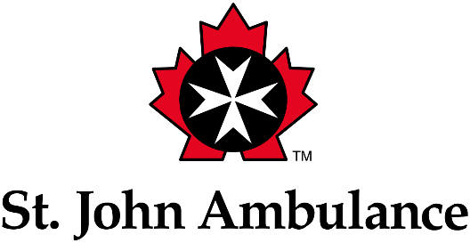

SAFE Work Manitoba/St. John Ambulance
Award for Excellence in Workplace First Aid

Nomination and Selection Criteria

- Nominees must be organizations that employ and service Manitobans.
- Both SAFE Work Manitoba and St. John Ambulance should mutually agree upon the selection.
- Nominees must:
  - not have had a workplace fatality in the past 36 months
  - not have been charged under the Workplace Safety and Health Act in the last 36 months
  - not be subject to an administrative penalty or prosecution under the Workplace Safety and Health Act
  - be in compliance with any outstanding order, as determined by the Workplace Safety and Health Branch (WSHB), and not have a history of compliance concerns, as determined by WSHB
  - be in good standing with the Workers Compensation Board if an account exists, which means:
    - the account is paid in full (e.g., can obtain a WCB clearance)
    - the firm has not been convicted of fraud against the WCB, a violation of the Act, claims suppression, discriminatory action or breach of return-to-work obligations in the last 36 months
    - the firm has not been issued an administrative penalty for claims suppression, discriminatory action or failure to comply with return-to-work obligations in the last 24 months
    - the firm is not under an active investigation for a violation under the Workers Compensation Act for claims suppression, discriminatory action or breach of return-to-work obligations, as determined by WCB Compliance
    - there are no outstanding remedial actions imposed on the firm to ensure compliance with preventing claims suppression, discriminatory action or return to work obligations, as determined by WCB Compliance
  - not engage in conduct considered by SAFE Work Manitoba to be inconsistent with participation in this awards program

Nominations must include:

- a brief history of the organization not to exceed one page in length
- a narrative supporting the nomination
- nominations and attachments that are typed

The nomination deadline is August 2, 2024.

Submit your nomination
Please contact Bryan Wall at St. John Ambulance at bryan.wall@sja.ca for more information and to submit your nomination.

Award presentation

The Lieutenant Governor of Manitoba will present the award at St. John Ambulance Council’s annual investiture ceremony in the fall.

