Incident Report - Sample
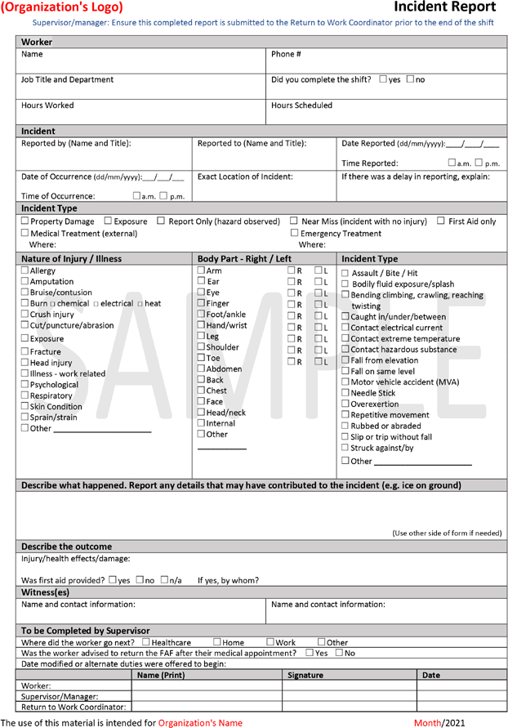

(Organization's Logo) Incident Report
Supervisor/manager: Ensure this completed report is submitted to the Return to Work Coordinator prior to the end of the shift

Corrective actions:
This section is to be completed by the supervisor with worker input.
What can be done to prevent or eliminate the hazard and incident from occurring again?
Additional comments or circumstances relevant to this incident:

