Physical Demands Analysis (PDA) - Sample

PHYSICAL DEMANDS ANALYSIS

Date: | Analyst:
Department: | Job Title:
Employer: | Employer contact:
Job Title: | Hours of Work/Days Worked:
Training:
Critical Job Elements:
Tools and Equipment Used:
Personal Protective Equipment:

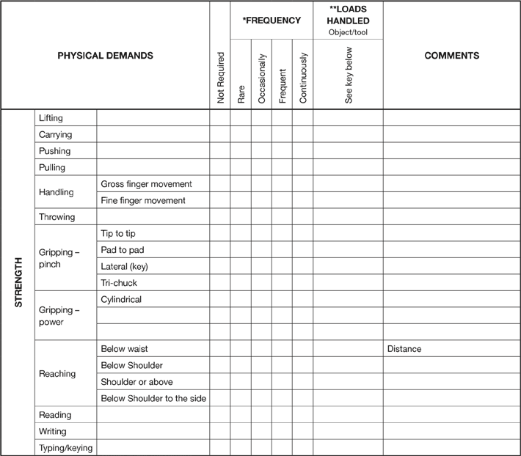

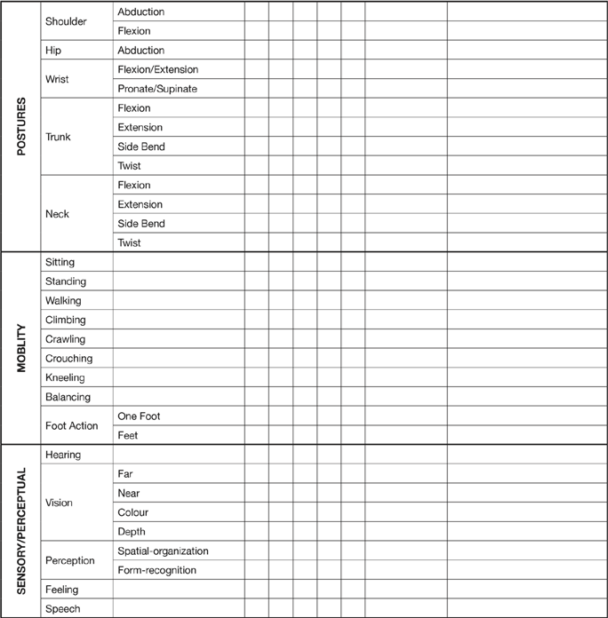

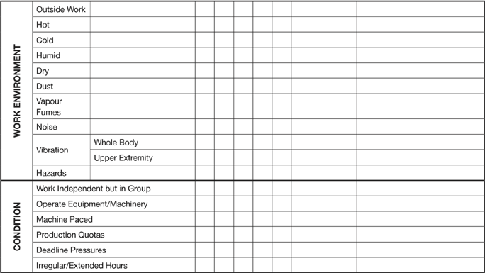
*FREQUENCY
Rare = 0-5%
(1-24 minutes over an 8 hour day)
Occasionally = 6-33%
(25 minutes – 2.5 hours over an 8 hours day
Frequently = 34-66^
(2.5 hours – 5.5 hours over an 8 hour day)
Continuously = 67-100%
(5.5 hours – 8 hours over an 8 hour day)
1 = LIMITED – up to 5 kg.
2 = LIGHT – up to 5 kg but less than 10 kg.
LOADS HANDLED
3 = MEDIUM – between 10 and 20 kg.
4 = HEAVY – more than 20 kg.
ADDITIONAL COMMENTS/PHOTOS

